# Visa bureau automation test plan

## Description

This document is to define the scope, strategy, deliverables, time and constraints of GUI automation testing for ETA visa online assessment function of website Visa bureau (<http://www.visabureau.com/>). Visa Bureau is an independent immigration consultancy providing a wide variety of global immigration and visa services

## Scope

Develop the GUI automated functional test scripts which modeling visa online assessment flow and evaluate EA pass/fail rule of ETA visa on Visa bureau site (Register/login > Enter applicant info > Verify pass/fail condition).

Link: <https://assessments.visabureau.com/australia/assessment/eta/default.aspx>

## Deliverables

* Test plan
* Test design
* Test script
* Test report
* Bug report (if any)

## Automation test approach

### Test tool and environment

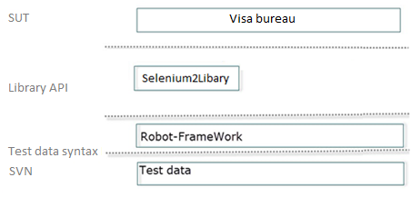

Figure 1: Robot - High level framework

* Test tool: Robot-framework
* Library: Selenium2Library
* Source code management: SVN <SVN link>
* CI: Jenkins <link>
* Client PC: Win7, 64 bit
* Browser: FF, IE, Chrome

### Process

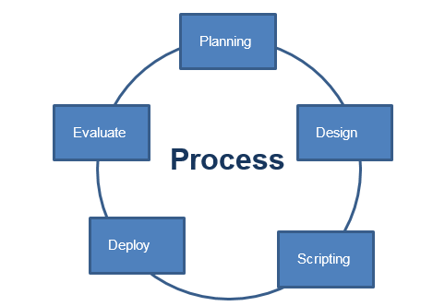

Figure 2: Automation process

* Planning: Select requirements to be automated, determine risks, and create schedule.
* Design: Create test data against pass/fail condition (data driven) or define test scenario (keyword driven), and peer review
* Scripting: develop keywords, and peer review
* Deploy job on Jenkins to run schedule
* Evaluate test result: Verify test report and do the corresponding actions
  + Log bugs if the script failed due to application errors.
  + Revise test script, or test data if bugs are from automation artifacts.
  + Review and update test-case if no bug found

### Naming convention

* Suite name: use the "lower_case_with_underscores".
* Keyword Names: use the "Cap Words" style.
* Global General Variable Names: use the "${CAP_WORDS}".
* UI Control Variable Names: use the "${capWord}”
* Keyword argument names: use the “${camWord}”

**Example**

*** Variables ***

#************************ Common Variables ****************************

${EMAIL_GLB} [test@abc.com](mailto:test@abc.com)

${PWD_GLB} abc123456

#************************* UI Elements ******************************

${categoryLocator} css=a.product_cat

${sCartLocator} css=a#shop_cart

*** Keywords ***

Login To Flower Shop ${account} ${password}

Update Account Info ${name} ${dob} ${sex}

### Scritpting best practices

* Design test before scripting
* Locate element by id, name, css for better performance
* Using data driven to evaluate EA pass/fail rule
* Create data generator engine keyword for which not relevent to the pass/fail rule
* Should use keyword “Select from list by value” when working with dropdown list since value normally does not contain special character (which might be encoded different between layers)
* Some selenium2libary keywords might not work with your website due to the new css style, write javascript to invoke the GUI event
* Create your own library in plain Python if the user keyword is complicated to model from existing RF keywords.

## Roles and responsibilities

|  |  |  |
| --- | --- | --- |
| Name | Role | Responsibilities |
| Ha Dinh Thi Thuy | Leader | * Create test plan * Review test design, data and script * CI management * Create test report |
| Nhung Nguyen Thi | Tester | * Create test design * Create test data * Create script * Peer review |
| Duong Nguyen Thuy | Tester |
| Trang Pham Thi | Tester |

## Entry criteria

* EA pass/fail rule is documented, reviewed by team, and approved by test leader
* Jenkins and SVN server is setup and ready for use

## Exit criteria

* The script run correctly on IE10, Firefox 31, and Chrome 31
* The other required deliverables are available
* Time up

## Risks

|  |  |
| --- | --- |
| Risks and issue | mitigation strategies |
| There was no SRS | Investigate and get req. from help content, then develop a pass/fail rules |
| Time commitment | Check task regularly |
| Low internet connection (result page timeout) | N/A |
| Site can go down | N/A |

## Details estimation and schedule

|  |  |  |  |  |  |  |  |
| --- | --- | --- | --- | --- | --- | --- | --- |
| ID# | Task | PIC | Estimation (hr) | Start date plan | End date plan | Status | Note |
| ETA_01 | Create test plan | Ha | 4 | 30 Jun |  | Done |  |
| ETA_01 | Review test plan | Tester | 1 | 30 Jun |  |  |  |
| ETA_01 | Update test plan | Hà | 2 | 30 Jun |  |  |  |
| ETA_01 | Create script for Register function | Nhung | 8 | 30 Jun |  |  |  |
| ETA_01 | Create script for Login function | Trang | 4 | 30 Jun |  |  |  |
| ETA_01 | Create test data for ETA EA | Trang | 8 | 30 Jun |  |  |  |
| ETA_01 | Create main script for ETA EA | Duong | 8 | 30 Jun |  |  |  |
| ETA_01 | Review script and build job on Jenkins | Ha | 2 |  |  |  |  |
| ETA_01 | Verify build result and log bug (if any) | Ha | 4 |  |  |  |  |
| ETA_01 | Fix script and data bugs | Tester | 8 |  |  |  |  |
| ETA_01 | Create test report | Ha | 4 |  |  |  |  |